To access your pdf certificate (only for certificates issued after 1st May 2016)

Log in to your instructor profile

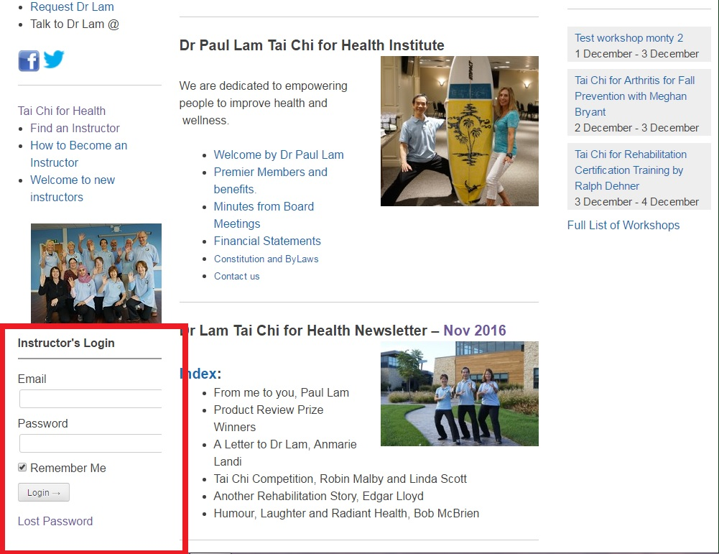

Under “Howdy”
Click on “View Profile”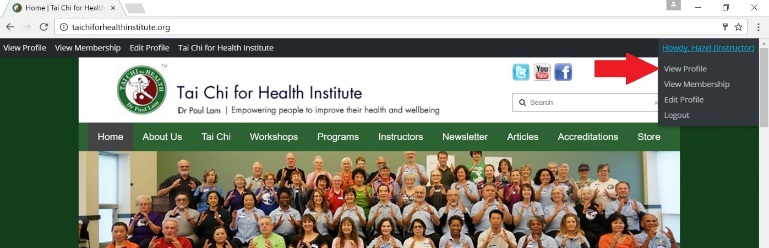
Find the new certificate in your list and next to it there are two links
“PDF Card” and “PDF A4
Click on the links to download and print your certificate and card
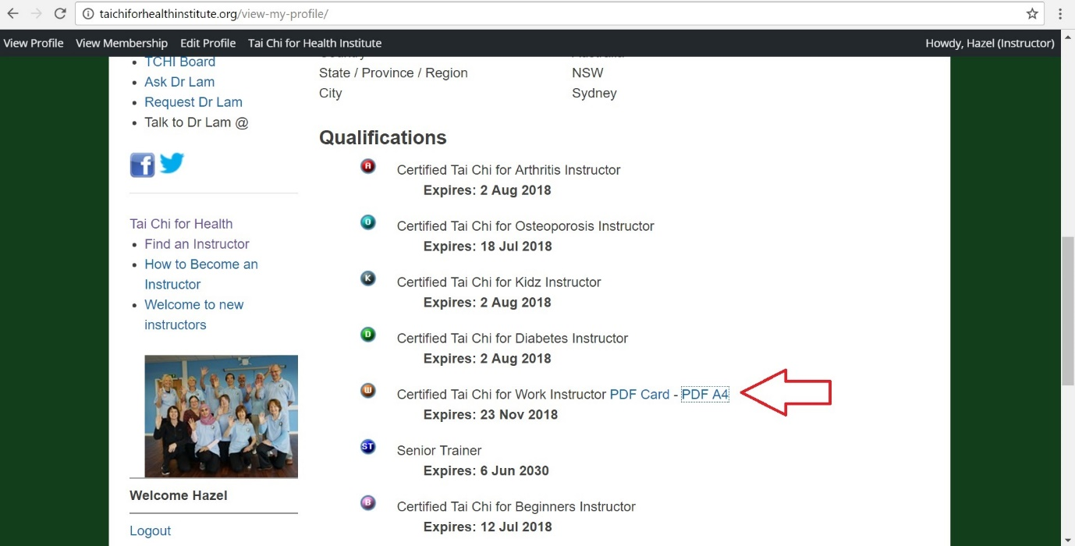
Congratulations on your new qualification!

